ASI Order Entry Import

Orders can be imported in csv format using the OF8 Import utility. The order input file must include one order header line and multiple order item lines.

Rather than requiring all of the order data to be supplied, the imported order will derive all necessary information from the required import fields.

If the import file has an estimate, a job will be created . Releases will also be auto-created similar to manual order entry. If a price is imported as 0, the appropriate price will be set based on standard order entry rules (e.g. quoted price or price matrix for stock item).

Once imported, the new orders will be placed in the O-W application where they can be reviewed and approved. Once approved, they can be processed exactly the same as orders that were added through O-U-1.

# N-K-1 OEIMPORT

Functionality is activated by setting the N-K-1 OEIMport logical value = YES.

The OEImport Character value field is used to identify the folder from which batch imports can be run. This is accomplished by simply hitting “Run Process” without specifying a single file path. The batch import will import every file that is located in the batch folder path, one file per order.

# O-F-8 Interface

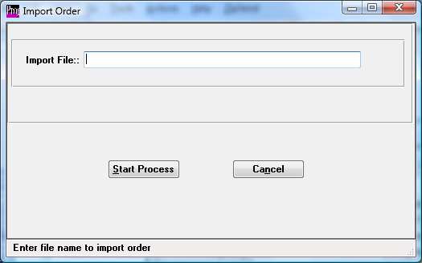

User can enter the full file path or use the F1 lookup to locate a single file for import. If they wish to run all files in the folder specified in the OEImport character value, leave the file path blank. The Run Process button will start the import.

Files imported in batch will be copied to the “Completed” folder (or “Errored” folder if the import was not successful).

# Import File Format

The first line in the import file is the import header. The fields are:

1. **“H” for header**
2. **Bill-to**
3. **Sold-to**
4. Due-Date
5. **Customer #**
6. Credit Card Acct Number
7. Credit Card VCode (the number on the back of the card
8. Credit Card Expiration Date
9. Credit Card Type
10. Estimate #
11. Quote #

Lines 2-n must contain the information for the Finished Good Items on the order. The fields are:

1. **“D” for order line item detail**
2. **Item #**
3. Customer Part #
4. **Quantity**
5. **UOM**
6. **Price**
7. Customer PO #
8. Due Date
9. Estimate #
10. Notes
11. Ship To
12. Quote #
13. Ship From Warehouse

Items in Bold are required. Item in blue are required to be valid values withing the system. Dates must also be valid dates.

See Excel (csv) file called “OeImportSample.csv” for more.